College Jobs, Bringing Students or graduates to better opportunities to build on their future.

## Team <Team D>

**Team Members**

PM Devon Beal

Dev1 Nick Gauthier

Dev2 Kaleb Hannan

Dev 3 Seth Vaughn

Design Nayan Sawyer

Design(NMD442) Ethan Suderley

Design(NMD442) Kearson Sutton

# Problem

One of the primary reasons most people go to college is to get a degree that shows they have the skills necessary to work a job in their chosen field. In many majors, however, students acquire enough skills to be employable well before they graduate. Computer science is a good example of this, where students are taught to code early on, and the later classes tend to be more theoretical. These high skill jobs pay much more than the jobs college students usually take like low wage retail or service jobs. Unfortunately, there is nowhere for them to find jobs that utilize the skills they are learning and that meet the requirements of a college student like part time, remote, etc. Computer science is a good example of this, where students are taught to code early on, and the later classes tend to be more theoretical. These high skill jobs pay much more than the jobs college students usually take like low wage retail or service jobs. Unfortunately, there is nowhere for them to find jobs that utilize the skills they are learning and that meet the requirements of a college student like part time, remote, etc.

# Prior Solutions

Kaleb Hannan

## Solution 1: LinkedIn

Overview paragraph on the solution:

LinkedIn is a job search engine and professional networking platform that allows you to find the right job or internship for you. They do this by allowing you to make a custom portfolio in which you can add skills, prior work experience, education, and certifications that you might to help yourself stand out and show recruiters that you are a good fit for their job. It allows you to add connections to help grow your professional network and also allows you to find jobs that you think you might be interested in and that fit your skill set. With that, it also lets you message your connections and recruiters so that you can talk to them directly over the website or so companies can reach out to potential candidates for their jobs. You can also view the feed of companies that you are interested in and your connections to see if they are looking for any new employees or if any of your connections are working on any cool projects.

Short paragraph on how YourApp will be different and why:

Major Help will be different because we are going to try and suit the jobs on the website to be more part-time and part-time online jobs that pay well and that you do not need a lot of experience to get that students can do while they are taking classes. Also, the jobs that we want to have on the site are supposed to help students broaden their knowledge about the field that they are studying and help them learn while they are getting paid to work on something. 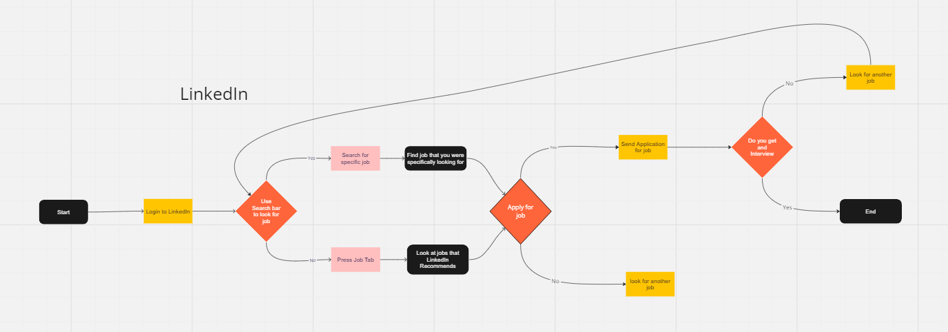

<https://miro.com/app/board/uXjVNf1Xqls=/?share_link_id=84568241948>

Devon Beal

Solution 2: Indeed

Indeed is a job search engine that allows you to send your resume, filter for specific jobs, and apply to said jobs. The way this is done is by either sending you to the company’s site or by using the essay apply button where they send the needed information to the company. The jobs you will mainly find for computer science are full time. Does have a variety of filter options besides location and job type. The nice part about the location filter is it will only go about 100 miles of your location. This does make it easier to filter jobs that are nowhere near you. Also, indeed will give an indication of how urgent the need for hires is with a company.

How will our app be different? Our app will be different by making it more accessible for entry level users such as college students/graduates. This will ensure they can get hired for a job from what they have learned in school and build upon their knowledge. The app will make it easier to find that short time work in a more personalized way. For example, it might help bring college students to small business owners in need of IT help and that can’t afford paying the rate the bigger businesses do. In short this app will improve the filtering options and open up better short term jobs.

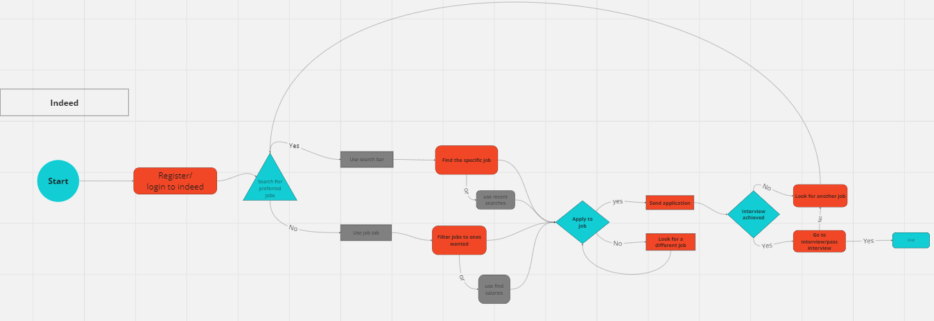

<https://miro.com/app/board/uXjVNf1Xqls=/?share_link_id=58033011259>

## Solution 3: Fiverr

Fiverr is an online marketplace that offers freelance services. Fiverr is unique in that freelancers are able to showcase their skills on their profile for customers to see and decide whether or not they want the freelancer’s services. The freelancers also have the freedom to set whatever pricing they want. The only issue is, it is up to the customer whether or not they want your services as the freelancer so it is not guaranteed that you will be making significant enough money.

Our app will be different by allowing college students to showcase their skills much like Fiverr does, but it will be advertising those college students to businesses who are more likely to hire them as part-time workers rather than customers deciding if they want to buy the college students’ services.

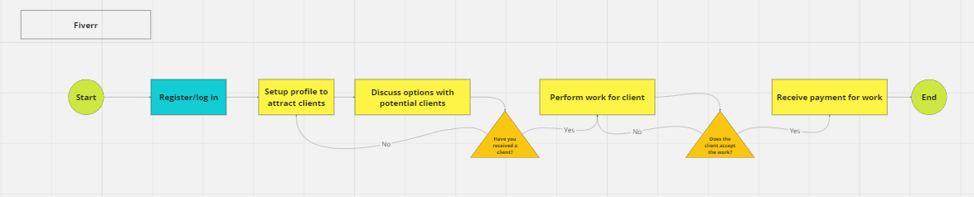

<https://miro.com/app/board/uXjVNf1Xqls=/?share_link_id=58033011259>

## Solution 4: Upwork

Upwork is an online freelancing platform that connects businesses and clients with freelancers from around the world. Upwork caters to a large range of freelance services, including writing, graphic design, web development, marketing, and more. Upwork includes a flexible API that allows many different kinds of interaction with the website and its content including searching for and posting jobs.

# College Jobs App

College Jobs is a job listing aggregator designed to help college students find part time and freelance jobs with good pay that will further the skills they are learning in college. Our users will be able to search for part time jobs *and* freelance work on the same site, and the platform will automatically filter out jobs that are not compatible with the requirements of students in college.

TaskFlow diagram:

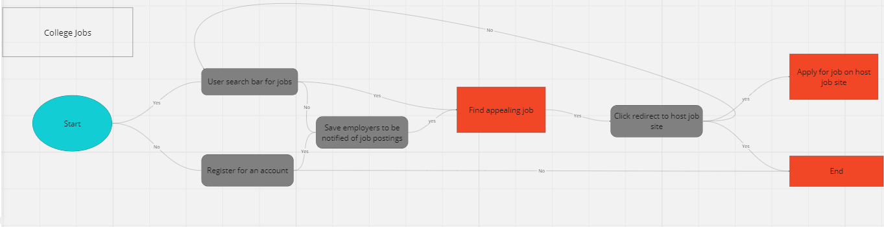

<https://miro.com/app/board/uXjVNf1Xqls=/?share_link_id=189206971375>

College Jobs is an app aiming to revolutionize the job search market for current college students. Users will be able to easily search and filter a curated selection of freelance and part time jobs scraped from other job hosts. Functionality will be similar to LinkedIn, Upwork, Fiverr, Indeed, and many other job sites, but without the clutter of high level positions and unreasonable application criteria. There will be a customizable job feed tab option to quickly look at newer listings relevant to each user.

The app will also have a resource page that reaches out to other sites that we recommend for learning the skills, and how to retain the new knowledge. These references are done by students that have personally used the software or site to learn from. Some of these sites are Comptia courses that can lead to certifications that look good on a resume or skill listing on the user's profile. The aggregator used to filter the jobs will use select keywords such as “job for credits” or “part time”, etc. This will help narrow the searches for student friendly jobs.

For reference on sites please refer to the SRS document that will be updated accordingly.

Website Layout Description

Pages

* Home page with site description and large central search bar
* Feed page that if logged in that shows a feed of recent job listings filtered according to profile, and if not logged in shows a “create account” page
* Search results page with sidebar for all filter controls
* User account page with user preferences and feed filter settings
* Login page
* Register page
* Job listing page with all information available about job listing

Shared Elements

* Header bar includes logo and name, centered search bar (except on home page), and a button that is either “login/register” if not logged in, or “account” if logged in